## LAB # 12

GAME THOERY IN ARTIFICIAL INTELLIGENCE

# Objective:-

**Implement Tic-Tac-Toe game using Minimax Algorithm in Game Theory**

# Lab Task:-

Finding optimal move in Tic-Tac-Toe using Minimax Algorithm in Game Theory?

**Code:**

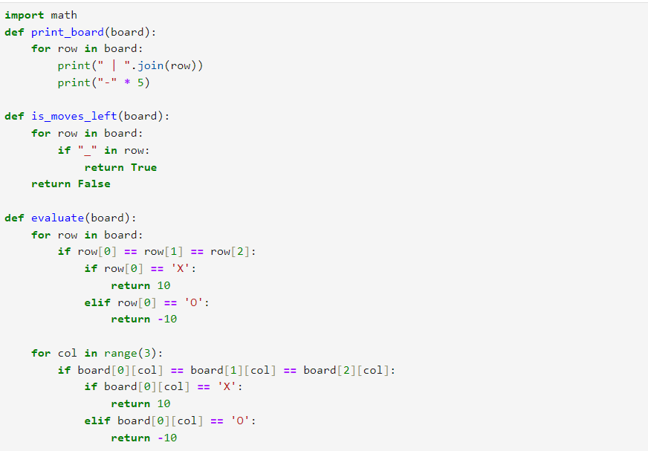

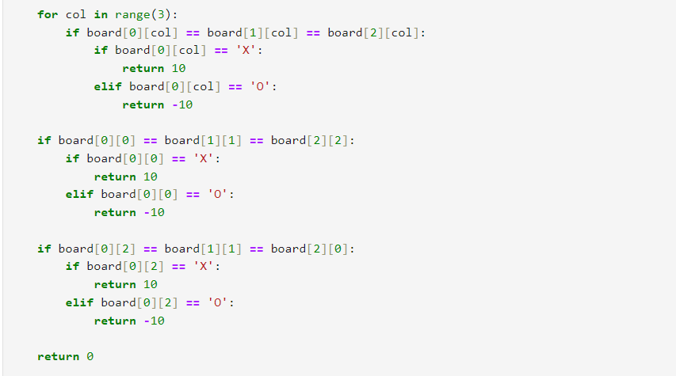

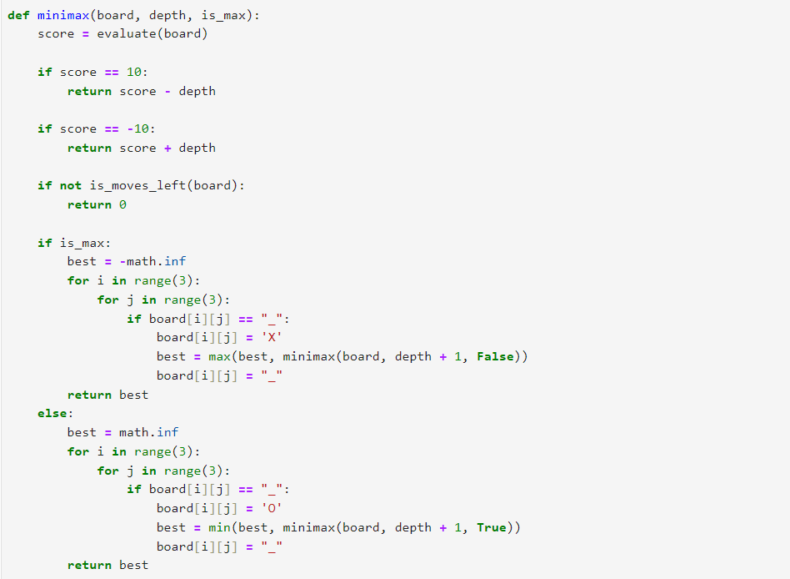

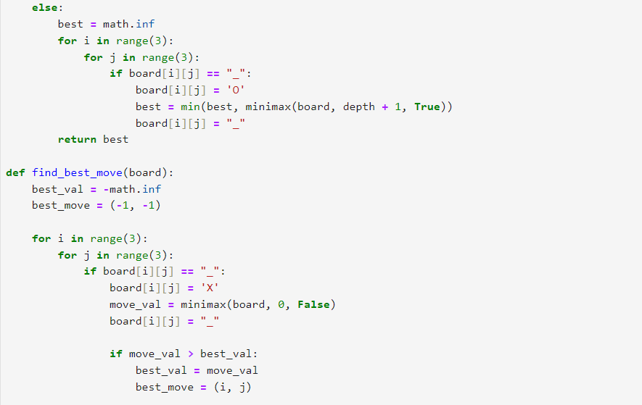

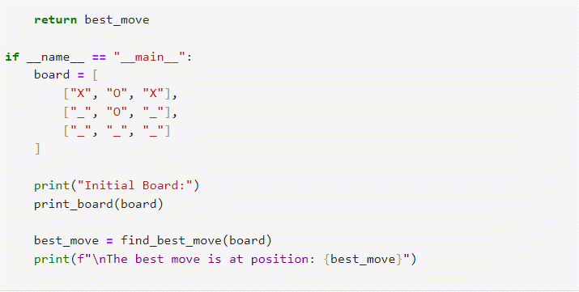

**Output:**

